* deploIn GitHub project, go to settings and add webhook with “jenkinsurl:port/github-webhook/” as below
* At the ending, / is important

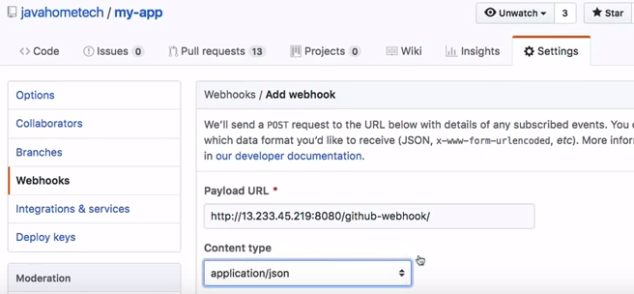

* After this, while creating Jenkins job after adding the github repo. Enable the below option under build triggers

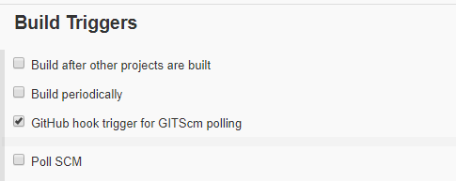

* So, whatever the Jenkins job is using that github repo and enabled with the above option, it will send a notification to Jenkins when a new commit occurs